

Hunt for Indian Restaurants in AUSTRIA



IBM Capstone Data Science Project  
Authored By: Deepankar Singh  
Date: 20th March 2019

### **INTRODUCTION/BUSINESS PROBLEM**

### The founder of one of the best Influencers and Food Community of India ‘SpicyTadka’ began her career with leading news channels like headlines today, Times Now and News X. After working for 7 years, she decided to pursue her passion for photography and blogging, eventually leading to Food Photography and Food Community. During her visit to Europe, she wanted to make a blog about the Indian food in Europe. And, they wanted to start their blog from the Centre of Europe – AUSTRIA.

### So, the team of SpicyTadka requested our Data Science team to find out the Best Indian Restaurant in AUSTRIA.

**DATA**

For providing the options for best Indian Restaurants in Austria to our client, we are using the data from Simplemaps.com & Foursquare API.

# **Simplemaps.com**

# Has a World Cities Database and itoffers a simple, accurate and up-to-date database of the world's cities and towns, which they have built it from the ground up using authoritative sources such as the NGIA, US Geological Survey, US Census Bureau, and NASA. We have taken the data for 81 cities of Austria and their coordinates from the website and save it our Git Hub repository. Below are the Links for both.

**Simplemaps.com :** <https://simplemaps.com/data/at-cities> **Git Hub Repository :** <https://github.com/Ekdeep0712/Capstone-Project-Coursera/blob/master/at.csv>

**Foursquare API**

For this project we are also using Foursquare API. Foursquare is a social location service that allows users to explore the world around them. One of the best characteristics of this API is, it can provide you the list of venues based on the coordinates and radius given. By using the “explore” feature with correct parameters, will give you a JASON file mentioning the below information.

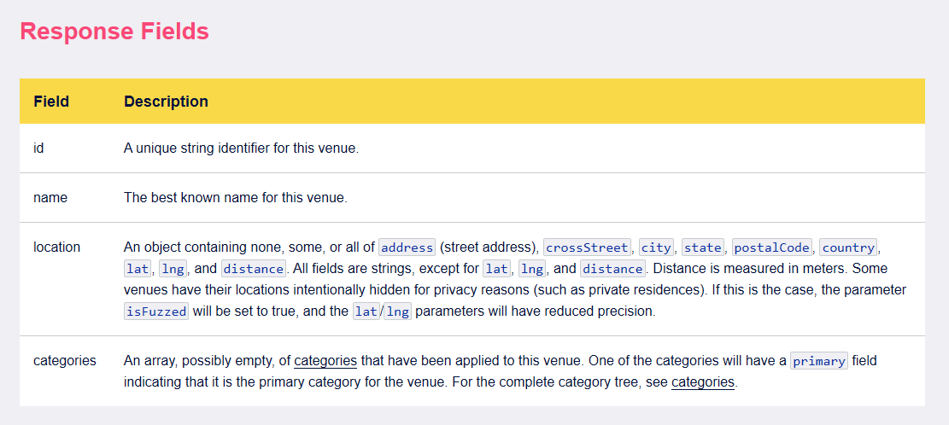

We used Foursquare to find the list of Indian Restaurants in Austria and to find the ratings of the restaurants.